Introduction to networking and osi model

Q1. Install Wireshark on your laptop, start a capture on your main network interface, and visit any website (like instagram.com). Stop the capture and note down the protocol names you see in the packet list.
Ans.
NO. | Protocol | Purpose
1 | ARP | Resolves IP address to MAC address on the local network
2 | DNS | Resolves domain names such as googleapis.com and Microsoft domains to IP addresses
3 | SSDP | Discovers devices and services on the local network
4 | IEEE 1905.1-CONTROL | Used for network-device discovery/control, commonly in home networking equipment

- Protocols observed in the Wireshark packet capture:
- ARP
- DNS
- SSDP
- IEEE 1905.1-Control
- The screenshot also shows DNS queries from 192.168.1.65 to the DNS server 192.168.1.254, along with ARP communication between devices on the local network.
Conclusion: The Wireshark capture successfully shows several protocols operating while the laptop was connected to the network.
Q2. Pick any 3 packets from your Wireshark capture and identify which OSI layer each packet mainly represents (for example, HTTP for Application layer, TCP for Transport layer, etc.). Hint: Use the Protocol column and Info details in Wireshark to help you map protocols to OSI layers.
Ans.
Packet No. | Protocol | Example Info | Main OSI Layer | Explanation
1 | ARP | Who has 192.168.1.65? Tell 192.168.1.254 | Layer 2 – Data Link | ARP is used to find the MAC address associated with an IP address on the local network.
3 | DNS | Standard query 0x045a A update.googleapis.com | Layer 7 – Application | DNS is an application-layer protocol that translates domain names into IP addresses.
25 | SSDP | M-SEARCH * HTTP/1.1 | Layer 7 – Application | SSDP is an application-layer protocol used for discovering devices and services on a local network.

- Note: A packet can contain information associated with multiple OSI layers. Here, the table identifies the main/highest-level protocol represented by the Wireshark Protocol column.
Q3. Create a colourful diagram of the OSI Model using any drawing tool (MS Paint, Canva, or even paper and upload a photo). For each layer, add a real-world example from apps you use daily (e.g., WhatsApp uses the Application layer, Instagram images use the Presentation layer, etc.).
Ans.
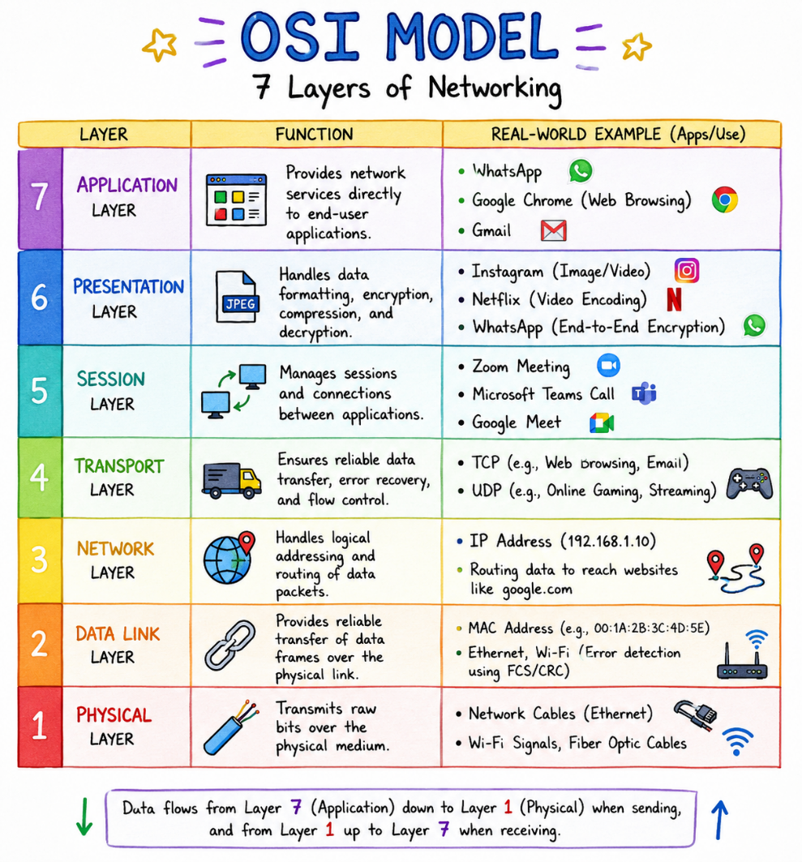
Q4. Explain how sending a message on WhatsApp travels through at least 4 layers of the OSI Model, describing what happens at each layer in your own words. Hint: Think about how your message is typed, packaged, sent over the internet, and received.
Ans. How a WhatsApp Message Travels Through the OSI Model
- When I send a message on WhatsApp, the data passes through several OSI layers before reaching the receiver.

OSI LAYER | What Happens When Sending a WhatsApp Message
7. Application | I type a message such as “Hello!” in WhatsApp and press Send. WhatsApp handles the message and prepares it for transmission.
6. Presentation | The message data is formatted and protected using encryption. WhatsApp uses end-to-end encryption so the message is protected while being transmitted.
4. Transport | The data is broken into smaller pieces and transported between my device and the destination using transport protocols. This helps manage delivery and communication between devices.
3. Network | The message is given logical addressing information, such as IP addresses. Routers examine this information and forward the packets toward the destination.
2. Data Link | The packets are placed into frames and prepared for transmission across the local network, such as my Wi-Fi router. MAC addresses help devices communicate
1. Physical | Finally, the data is transmitted as electrical, radio, or optical signals—for example, from my phone through Wi-Fi radio signals to the router.

- At the Receiver
- The process happens in reverse: the receiver's device receives the signals at Layer 1, processes the data upward through the layers, decrypts/reassembles it as appropriate, and WhatsApp finally displays “Hello!” at the Application layer.
- In simple terms:
- Type message → encrypt/format → transport → route → frame → transmit → receive → process → display.

